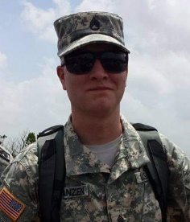
Brandon C. Franzen Memorial 5k Run/Walk
Hosted by: Brandon C. Franzen Memorial Foundation, Inc. 501(c)(3) Nonprofit Corporation
Saturday, July 16, 2022
Location: Western (Latham) High School, 7959 State Route 124, Latham, OH 45646
Fill out this form or register at www.TriStateRacer.com
Same day registration begins at 7:00 AM. Race begins promptly at 8:00 AM.
Please print legibly and fill out entire form.
Checks can be made out to Brandon C. Franzen Memorial.
Please return form & waiver to: C/O Katie Davis, 2103 Hackleshin Rd, Peebles, OH 45660
Proceeds will benefit Operation Untiltheresnone: No Buddy Fights Alone and Dress, Right, Dress, Inc.
5k Run/Walk Fee: $25.00 (Note that Virtual Option is $30)
All paid participants who register by 12:00 AM on July 1, 2022 are guaranteed a t-shirt. Registrations after this date will not receive their shirt on race day. Every registration gets a swag bag!
In-Person: Medals awarded to all finishers. Special awards for top 3 male/ 3 female runners & top 3 walkers.
Virtual Participants: Finishing time must be submitted on www.TriStateRacer.com
by deadline to receive a finisher’s medal.
First & Last Name: ___________________________________________________________
Age on race day: ________ Date of birth: _____/_____/_____.
Male or Female (Circle One) Run or Walk (Circle One) In-Person or Virtual (Circle One)
Address: _____________________________________________________________________
City: ____________________________ State: __________ Zip Code: _______________
Telephone: (____) ____-______. Email: __________________________________________
T-shirt size: (Shirt guaranteed on race day for registrants who register or have postmarked by July 1, 2022.)
Youth small ___ Youth medium ___ Youth large ___.
Adult small ___ Adult medium ___ Adult large ___ Adult x-large ___
Adult xx-large ___ (+ $2). Adult xxx-large ___ (+ $2). Adult xxxx-large ___ (+ $2)

